Westminster Presbyterian Church PCA Celebrates Sesquicentennial
This past Sunday, October 29th was a day of remembrance and celebration as members and friends of Westminster Presbyterian Church PCA gathered for a special time of worship and praise. Joined by sister churches of the Presbytery of Northern Illinois (All Souls in Champaign, Amazing Grace in Watseka, and Redeemer Church in Peoria), the congregation rejoiced in all that God has done throughout the past 150 years since the church’s inception November 1, 1867. The service marked several other milestones: the 500th anniversary of the Protestant Reformation, the 30th year of Westminster belonging to the Presbyterian Church in America, the 10th anniversary of All Souls, and the 1st anniversary of Amazing Grace.
Hymns recounting God’s faithfulness, mercy, power and grace were joyfully sung, as were verses from Psalm 45 extolling the majesty of the everlasting God. Elder Jim Golden and Rev. Dr. Steve Jones led the worship liturgy which included a prayer of confession of sin followed by an assurance of pardon from Isaiah 53:1-6, as well as a responsive reading of Psalm 105:1-8 which begins with praise and ends with God’s faithfulness to a thousand generations. Visiting pastors Rev. Luke Herche (All Souls) and Rev. Scott Killy (Amazing Grace) read passages from the Old and New Testaments which furthered the tenor of awe and worship. Rev. Mark Henninger (Redeemer Church) preached from Judges 11:12-28 on the importance of “Knowing Church History”, bringing out the centrality of the greatest events in history- Jesus Christ, God the Son, coming to earth to secure the salvation of his people through his life, death, resurrection and session as Lord, King and Head of his Church. Fittingly, the final hymn of response was “The Church’s One Foundation” which is a song of praise and prayer to her sustaining and defending Lord, as the church will persevere on earth until being united with Jesus at last.
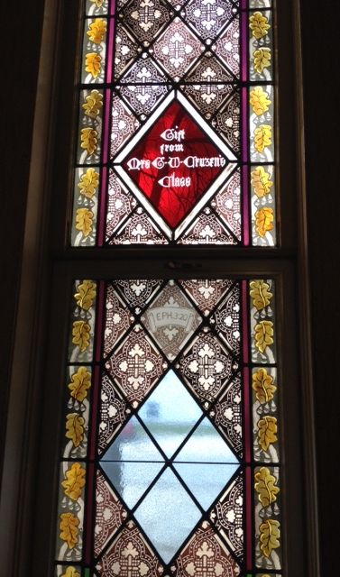
Historic evidence of the covenant love of God is seen primarily through the generations of families which have received and rested in his mercy and grace, but also through the record of 36 pastors which have served at Westminster through its 150 years by “Holding Forth the Word of Life”. It is a marvelous thing to consider God’s grace in calling broken, sinful, forgiven men as pastors, to preach his Word, to tell of his wondrous works- to call his people to come and worship him. Ministers called to preach “the unsearchable riches of Christ…so that through the church the manifold wisdom of God might now be made known…” (Eph. 3:7-10)
The beautiful church building which houses Westminster was erected in 1872 on the corner of Center and Vermilion Streets. The manse (or parsonage) next door was erected in 1894 and has always been the home of the current pastor and his family except for one brief period. In 1899 the church building was remodeled so that the sanctuary would face east instead of west. In 1907 a water powered pipe organ was installed which remained in working order until 1957. The original pipes are still a lovely element of the sanctuary. In 1984 the church was once again remodeled to add new restrooms and upstairs Sunday School rooms, and in 1988 the basement was modified to include a full kitchen and dining hall. The upstairs fellowship room was renovated in 2008 with a new kitchen installed. Throughout the life of the church, the original stained-glass windows have been maintained which artfully reflect some of the church’s earliest members’ names, initials and SS classes.
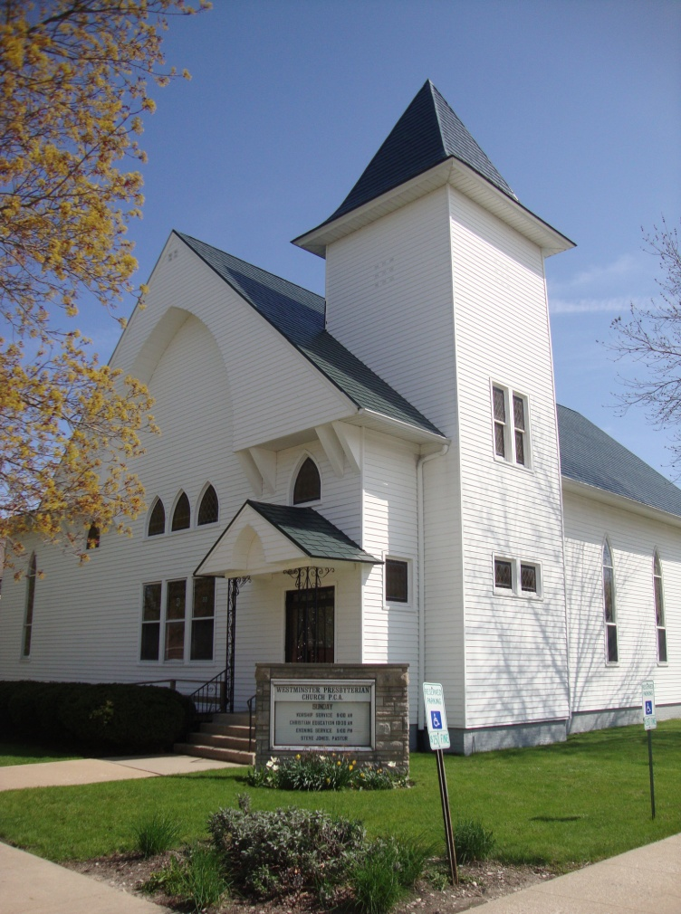
Initially founded as First Presbyterian Church, it remained Presbyterian for many years. Following WWII some of the church members believed that their denomination was going in the wrong direction in a number of ways. Because of this they felt the need to remove themselves from their beloved denomination in 1947 to become Westminster Bible Church. A newspaper clipping captures the basis for departure. “In recent years there has been a manifest trend in the teaching of those who control and direct the [denomination] away from the doctrines of the infallibility of the Word of God, the virgin birth of Jesus Christ, the necessity of His atoning death, the physical resurrection, Christ’s personal return, and other doctrines which are fundamental and vital.” Later, with a desire for a more robust Reformed theology, as well as their continued eagerness to uphold biblical fidelity, the church members voted to return to the church’s Presbyterian roots and became Westminster Presbyterian Church PCA in June of 1987. They joined the Presbyterian Church in America, a conservative and Reformed denomination which was founded in Birmingham, Alabama in 1973.
Through years of plenty, through lean years, through years of transition and through years of constancy, Westminster remains a people of hope in Jesus Christ. “The LORD has done great things for us; we are glad.” Psalm 126:3

